**HIMANSI RUDRA**

**SEC A**

**422156**

**Main.c**

#include <stdio.h>

#include "head.h"

void main() {

int n = 12;

fibonacci(n);

fibonacciSum(n);

}

**Find fibonacci sequence**

#include <stdio.h>

void fibonacci(int n) {

int first = 0, second = 1, next, i;

printf("Fibonacci sequence for %d numbers: \n", n);

for (i = 0; i < n; i++) {

if (i <= 1)

next = i;

else {

next = first + second;

first = second;

second = next;

}

printf("%d ", next);

}

printf("\n");

}

**Find fibonacci sum**

#include <stdio.h>

long long fibonacciSum(int n) {

long long first = 0, second = 1, next, sum = 0;

printf("Fibonacci numbers until exceeding %d: ", n);

while (1) {

next = first + second;

// If next Fibonacci number exceeds the threshold, break the loop

if (next > n)

break;

// Add next Fibonacci number to sum

sum += next;

// Update first and second for the next Fibonacci number

first = second;

second = next;

printf("%lld ", next);

}

printf("\n");

return sum;

}

**Head.h**

int fibonacci(int n);

int fibonacciSum(int n);

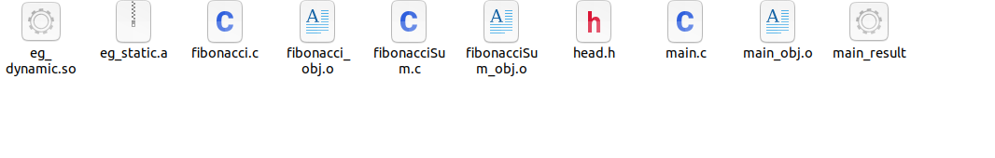

Dynamic:

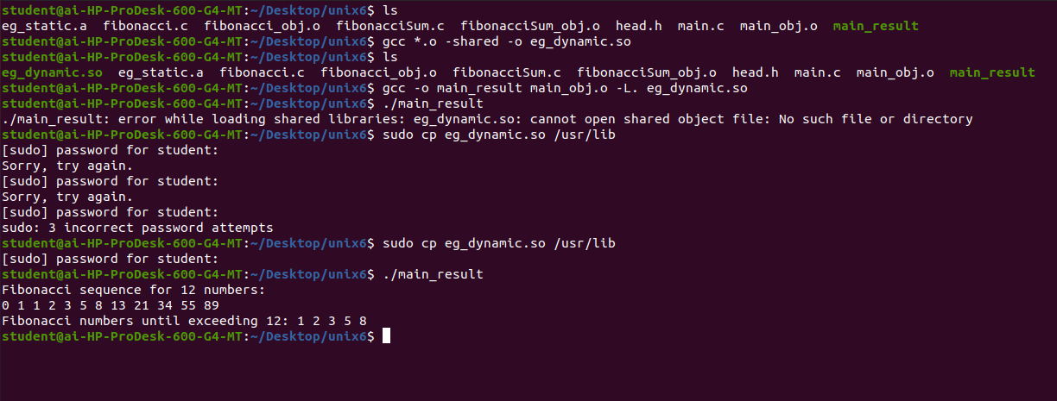

Static:

